ANNEX
MS01 – Registration Form
Required data for Website’s Registration
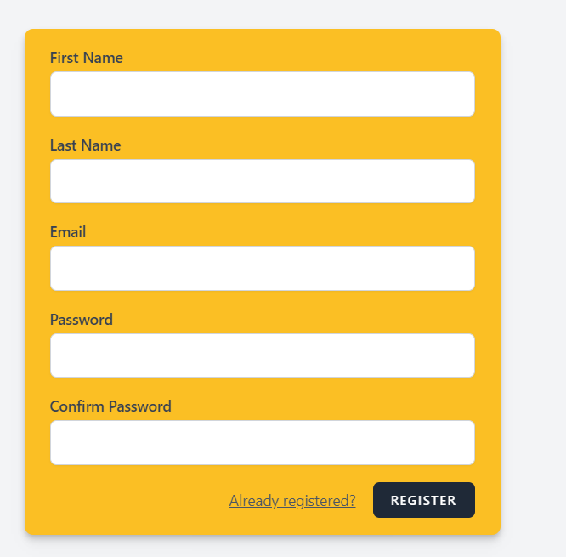
FIRST NAME
LAST NAME
EMAIL
PHONE NUMBER
COUNTRY OF RESIDENCE
PASSWORD
18+ YEARS OLD CONFIRMATION

If you refuse to provide the above information, we will not be able to provide you with the service.

Additional Data (Optional)

RESIDENCE ADDRESS
PHONE NUMBER
PROFILE PICTURE

